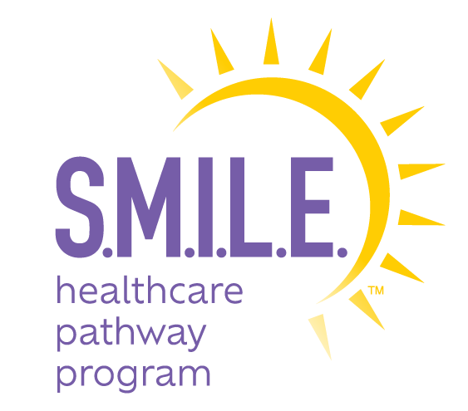

The S.M.I.L.E. (Student Mentoring with Immersive Learning and Enrichment) Healthcare Pathway Program is a partnership between Henry Schein, Inc., the National Dental Association, and other professional associations to help mentor future healthcare professionals, enhance health literacy, expand diversity in the healthcare workforce and ultimately improve health and overall outcomes in underserved communities nationwide.

**Submit Completed Applications Online at** [**https://ndaonline.org/smile-program/**](https://ndaonline.org/smile-program/)

**or email the below application to:** [**SMILEHealthcarePathwayProgram@gmail.com**](mailto:SMILEHealthcarePathwayProgram@gmail.com)

**Deadline: March 31**

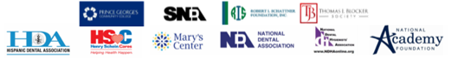**ELIGIBILITY**

* Students from underrepresented communities entering 11th grade who are in good standing academically
* Students who are financially disadvantaged will be given priority
* Students who are interested in learning more about careers in dentistry or the healthcare community

**STUDENT INFORMATION**

**Legal First Name**: Insert text here. **Legal Last Name:** Insert text here.

**Preferred Name**: Insert text here. **DOB**: Choose date. **Gender**: Choose an item.

**Address**: Insert text here **City, State**: Insert text here **Zip**: Insert text here

**Email**: Insert text here. **Phone**: Insert text here. **Race**: Choose an item.

**School**: Insert text here. **Grade**: Choose an item. **T-Shirt Size**: Choose an item.

**Program Choice:** Choose an item. **Prior Experience in Healthcare:** Insert text here

**Personal Statement:** *Please provide a few sentences as to why you’d like to participate in this program.*

Click or tap here to enter text.

**LEGAL GUARDIAN INFORMATION**

**Relationship to Student:**Insert text here

**Legal First Name**: Insert text here. **Legal Last Name**: Insert text here.

**Email**: Insert text here **Cell Phone**: Insert text here

**Occupation**: Insert text here. **Employer**: Insert text here.

**GUARDIAN PERMISSION**

I, Click or tap here to enter text., the parent/legal guardian of Click or tap here to enter text. grant for him/her to participate in the S.M.I.L.E. Healthcare Pathway Program. Upon student acceptance, legal guardians will need to sign and submit to various waivers.

_________________________________________ ______________________________

Parent/Guardian Signature Date